📚 Udemy Courses Data Analysis Report
1. Introduction
This project analyzes Udemy’s course dataset to uncover insights into online learning trends. By exploring attributes such as course titles, subjects, pricing, enrollment, ratings, and publication dates, the study aims to identify patterns in learner preferences, course popularity, and market dynamics in the e-learning industry.
2. Dataset Overview
- Attributes (typical columns): Course ID, Title, Subject, Price, Number of Subscribers, Number of Reviews, Level (Beginner/Intermediate/Expert), Published Timestamp.
- Size: Large dataset covering thousands of courses across multiple subjects.
- Target Use: Trend analysis, recommendation insights, and pricing strategies.
3. Objectives
- Explore subject-wise distribution of courses.
- Analyze pricing strategies and their impact on enrollments.
- Identify top-performing courses based on subscribers and reviews.
- Detect trends in publication dates (e.g., growth of online learning over time).
- Build visualizations to highlight relationships between price, ratings, and popularity.
4. Tools & Libraries
- Python – core programming language
- Pandas & NumPy – data cleaning and manipulation
- Matplotlib & Seaborn – visualization
- Jupyter Notebook – documentation and reproducibility
5. Key Analyses
Exploratory Data Analysis (EDA)
- Distribution of courses by subject (e.g., Business, Web Development, Music).
- Price distribution and free vs. paid course comparison.
- Subscriber counts across different subjects.
Outlier Detection
- Identify courses with unusually high enrollments or reviews.
Visualizations (placeholders for figures)
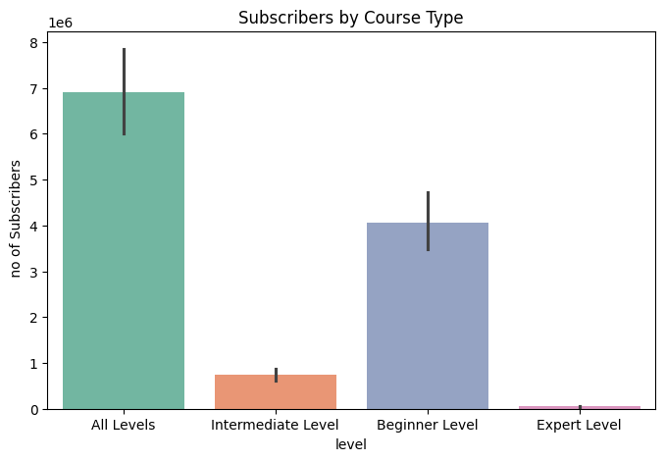
- Bar Chart: Subscribers by Course Type compares the popularity of Udemy courses across different levels

- Histogram: Distribution of course prices.
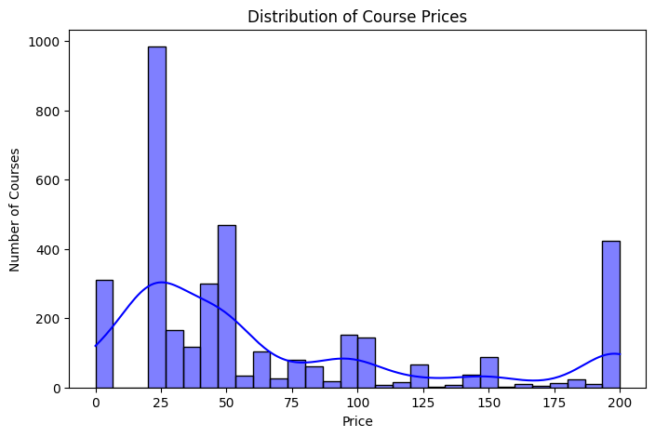
- Line Plot: Growth of courses published over time.

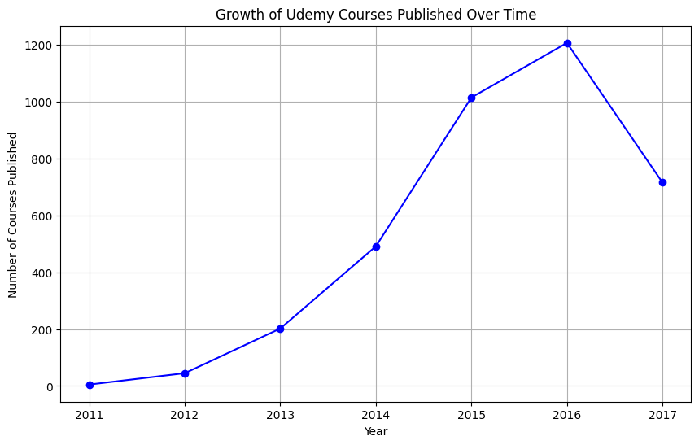

- Scatter Plot: Price vs. number of subscribers.

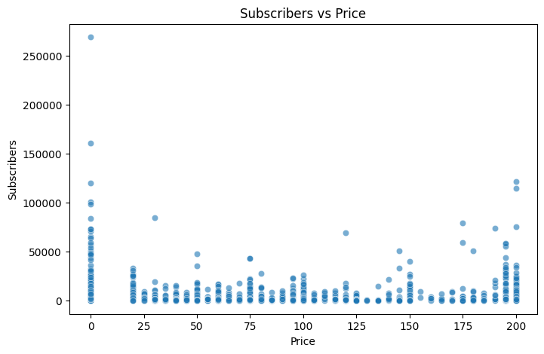
Statistical Analysis
- Correlation between price, reviews, and subscribers.
- Hypothesis testing: Do free courses attract significantly more subscribers than paid ones?
6. Insights
- Web Development and Business courses dominate the platform.
- Free courses attract higher enrollments but often fewer reviews compared to paid ones.
- Pricing strategies vary widely, with mid-range priced courses showing strong subscriber engagement.
- Publication trends indicate rapid growth in online learning after 2015.
7. Conclusion
This analysis demonstrates how Udemy’s dataset can be leveraged to understand learner behavior and course performance. By combining statistical methods, visualization, and trend analysis, the project provides actionable insights for instructors, learners, and stakeholders in the e-learning industry.

